**STORED PROCEDURES**

**Introduction**:

* A stored procedure is a prepared SQL code that you can save,so the code can be reused again.
* So if you have an SQL query that you write over and over again , save it as a stored procedure , and then just call it to execute it.
* We can invoke the procedures by using triggers, other procedures and applications such as Java ,Python,PHP etc  It was first introduced in MySQL **version 5**. Presently, it can be supported by almost all relational database systems.
* If we consider the enterprise application, we always need to perform specific tasks such as database cleanup, processing payroll, and many more on the database regularly. Such tasks involve multiple SQL statements for executing each task. This process might easy if we group these tasks into a single task. We can fulfill this requirement in MYSQL by creating a stored procedure in our database.

Syntax To Create a Stored Procedure:

DELIMITER &&

**CREATE** **PROCEDURE** procedure_name [[IN | **OUT** | INOUT] parameter_name datatype [, parameter datatype]) ]

**BEGIN**

  Declaration_section

     Executable_section

**END** &&

DELIMITER ;

**IN parameter**

It is the default mode. It takes a parameter as input, such as an attribute. When we define it, the calling program has to pass an argument to the stored procedure. This parameter's value is always protected.

**OUT parameters**

It is used to pass a parameter as output. Its value can be changed inside the stored procedure, and the changed (new) value is passed back to the calling program. It is noted that a procedure cannot access the OUT parameter's initial value when it starts.

**INOUT parameters**

It is a combination of IN and OUT parameters. It means the calling program can pass the argument, and the procedure can modify the INOUT parameter, and then passes the new value back to the calling program.

**Features Of Stored Procedures:**

* Stored procedures help increase the performance of the applications .Once created,stored procedures are compiled and stored in the database.
* Stored procedures helps to reduce the traffic between application and database server.
* These are secure.

**Differences between Functions and Stored Procedures :**

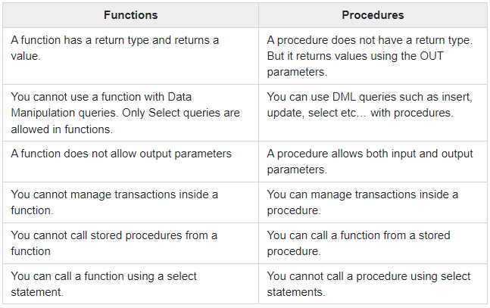

**Concerns Over Using Stored Procedures :**

While there are many perks to using stored procedures, there are a few things to be aware of:

* **Testability.**Business logic, which is encapsulated in stored procedures, is difficult to test. If there are data errors, you won’t know until runtime.
* **Debugging.** Debugging stored procedures is challenging but possible. However, you’re at the mercy of a database profiler to track down an application issue or debug your database.
* **Versioning.**Stored procedures do not support versioning. However, you can work around this issue by putting stored procedures into a version control system.